WITHPOINTS
Robot-Mounted 3D Vision System

NOONVIT ONE
User Manual
Installation · Connection · Operation · Maintenance
Model NV-ONE-N350 · Hardware Rev. 1.0

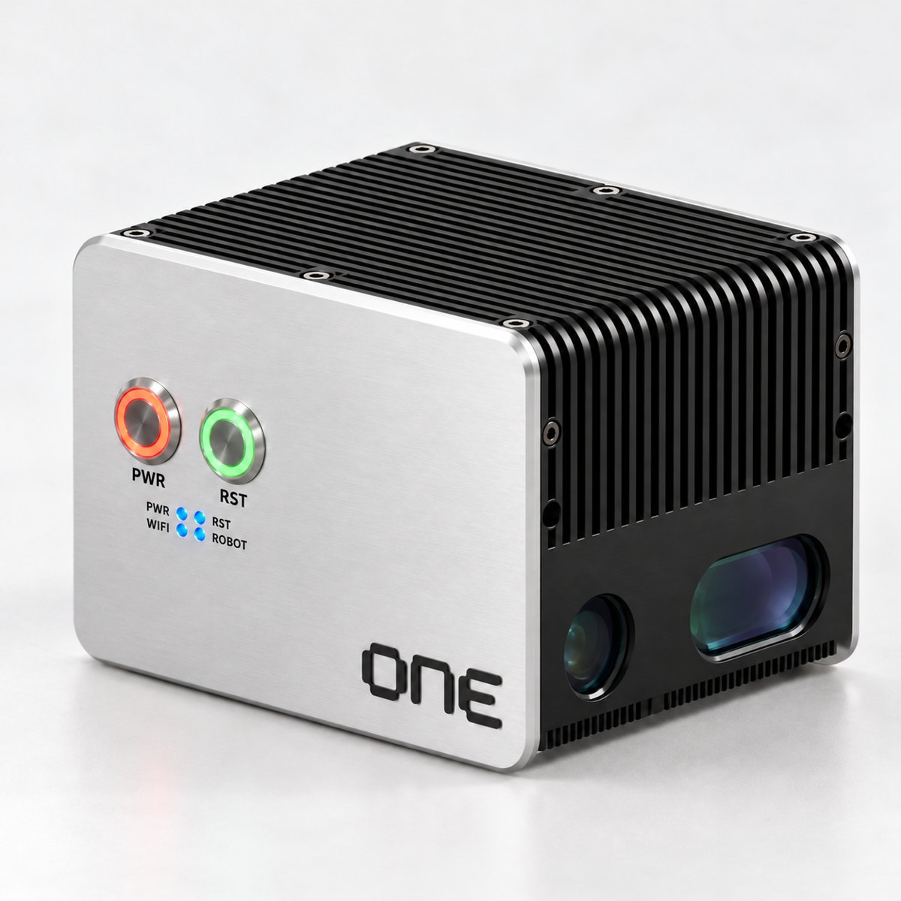

Document No.  NVO-UM-EN-002 | Revision  Rev. 2.1 | Issued  October 21, 2026 | Language  English
Keep this manual near the product so that it can be referred to at any time during installation and operation.

Copyright and Notices
Copyright © 2026 WithPoints Co., Ltd. All rights reserved.
This document is copyrighted by WithPoints Co., Ltd. No part of this document may be reproduced, distributed, transmitted, or converted into any other form without the prior written consent of WithPoints Co., Ltd.
NOONVIT and NOONVIT ONE are trademarks of WithPoints Co., Ltd. Mech-Eye is a trademark or registered trademark of Mech-Mind Robotics Technologies Ltd.; NVIDIA and Jetson are trademarks or registered trademarks of NVIDIA Corporation; Chrome is a trademark or registered trademark of Google LLC; Edge is a trademark or registered trademark of Microsoft Corporation. All other product and company names are trademarks of their respective owners.
The contents of this document are subject to change without notice for product improvement. The specifications, screens, and figures in this document are for illustration purposes and may differ from the actual product. Contact the manufacturer for the latest version of this document.
The manufacturer is not liable for damage resulting from failure to follow the instructions in this document, from unauthorized modification of the product, or from the use of accessories not specified by the manufacturer.
Manufacturer
Company | WithPoints Co., Ltd.
CEO | Dong-kyun Cho
Business Registration No. | 501-86-01277
Address | 2F, 8 Gukjegwahak 11-ro, Yuseong-gu, Daejeon 34002, Republic of Korea
Tel. | +82-42-721-0412
Email | info@withpoints.co.kr

Revision History
Revision | Date of Issue | Description of Changes
Rev. 1.0 | September 2026 | First edition
Rev. 2.0 | October 21, 2026 | Added account login, recovery functions, and installation record card
Rev. 2.1 | October 21, 2026 | Complete restructuring of the document; expanded product specifications, safety information, and warranty terms; added model number (NV-ONE-N350) and hardware revision

Related Documents
- Process App Manual — process-specific work procedures such as creating inspection recipes and viewing results
- Calibration App Manual — hand-eye calibration procedure
- Mounting Drawing — bracket mounting hole specifications, spacing, and tightening torque
- Warranty Certificate and Supply Agreement — warranty terms and scope of service
About This Manual

Intended Audience
This manual is written for installers who mount NOONVIT ONE on a robot and for shop-floor operators who use it in daily operation. Installation, wiring, and calibration must be performed by personnel trained in industrial robots and electrical equipment.

Document Structure
Chapter | Contents | Primary Readers
1 Safety Precautions | Safety information that must be read before use, installation environment, regulatory compliance | All
2 Product Description | Package contents, part names, product specifications | All
3 Installation | Mounting on the robot, cable connection, powering on | Installers
4 Network Connection and Access | Wired and wireless connection, browser access | Installers
5 Account Login | NOONVIT account login, guest access, logout | All
6 Screen Layout and Status Indication | Menus, device connection status, status indicators on the unit | All
7 Process Apps | Running and opening process apps | Operators
8 Operation | Initial installation check, daily start-up and end-of-work procedures | Operators
9 Maintenance | Inspection and cleaning, connection recovery, restart and reset | Installers
10 Troubleshooting | Check sequence by symptom, requesting technical support | All
11 Warranty and Service | Warranty terms, service contact | All
Appendix | Installation record card, pre-handover checklist | Installers

Conventions
In this manual, safety-related information is identified by the following symbols.
WARNING | Indicates a situation in which failure to follow the instructions may result in death, serious injury, or severe damage to equipment.

CAUTION | Indicates a situation in which failure to follow the instructions may result in minor injury, product damage, or data loss.

NOTE | Supplementary information for correct and efficient use of the product.

On-screen menus and buttons are shown in square brackets, for example [Device Info] and [Settings > Network & Time]. Buttons and connectors on the unit are shown exactly as marked on the housing, for example PWR and ETH.
Contents
1 Safety Precautions 5
1.1 General Safety Precautions 5
1.2 When to Stop Immediately 5
1.3 Installation and Electrical Safety 5
1.4 Light Source Safety 5
1.5 Installation Environment 5
1.6 Regulatory Compliance 5
1.7 Disposal 5
2 Product Description 5
2.1 Product Overview 5
2.2 Package Contents 5
2.3 Part Names 5
2.4 Specifications 5
3 Installation 5
3.1 Pre-Installation Checks 5
3.2 Mounting on the Robot 5
3.3 Cable Connection 5
3.4 Powering On 5
3.5 Removal 5
4 Network Connection and Access 5
4.1 Access Address 5
4.2 Wired Connection 5
4.3 Wi-Fi Connection 5
5 Account Login 5
5.1 Login 5
5.2 When Login Is Required Again 5
5.3 Guest Access 5
5.4 Logout 5
6 Screen Layout and Status Indication 5
6.1 Main Menus 5
6.2 Device Connection Status 5
6.3 Status Indicators on the Unit 5
7 Process Apps 5
7.1 Running and Opening an App 5
7.2 App Status After Restart 5
7.3 If the App Window Does Not Open 5
8 Operation 5
8.1 Initial Installation Check 5
8.2 Daily Start-Up 5
8.3 End of Work 5
8.4 If the Power Is Lost Unexpectedly 5
9 Maintenance 5
9.1 Periodic Inspection and Cleaning 5
9.2 Recovering Connections from the Screen 5
9.3 Restarting and Resetting with the Button 5
9.4 Log Retention 5
10 Troubleshooting 5
10.1 Check Sequence by Symptom 5
10.2 Requesting Technical Support 5
11 Warranty and Service 5
11.1 Warranty 5
11.2 Service Contact 5
A Appendix 5
A Installation Record Card 5
B Pre-Handover Checklist 5

01

Safety Precautions
Read this chapter in full and make sure you understand it before installing or using the product for the first time. The safety precautions in this chapter assume that the product is used within its design limits.

1.1 General Safety Precautions
WARNING | NOONVIT ONE is a device intended to be mounted on an industrial robot. When working within the operating range of the robot, give priority to the safety instructions of the robot manufacturer and the safety regulations of your site.  The connection indications on the screen, closing an app window, logging out, and the status indicators on the unit do not mean that the robot or the equipment has stopped. In an emergency, always use the emergency stop devices at the site.

- Use the product only for the purpose and in the environment described in this manual.
- Do not disassemble or modify the product. There are no user-serviceable parts inside.
- Installation, wiring, and removal must be performed by trained personnel with the robot and equipment stopped and the power disconnected.
- Keep this manual with the product, and hand over the manual together with the product when transferring it.

1.2 When to Stop Immediately
If any of the following is observed, stop the robot and the equipment according to the site emergency stop procedure and notify the person in charge. If an electrical fault is suspected, make the area safe and then unplug the AC plug of the power adapter.
- Cracks in the housing, a damaged optical window, or damaged cable sheathing are visible
- A burning smell, smoke, or heat noticeably higher than usual is detected
- The robot or surrounding equipment moves unexpectedly

1.3 Installation and Electrical Safety
WARNING | Use only the supplied 24 V power adapter and power cable. Connecting AC power directly to the unit or wiring the connector pins yourself may cause electric shock, fire, or product damage.

CAUTION | Do not cover or block the heat sink on the top of the unit. Do not touch the heat sink during operation or immediately after power-off, as it is hot.  When removing the unit, support it so that it does not fall. The unit weighs approximately 2.55 kg.  Do not disconnect the power or unplug cables while an image is being captured or data is being saved. Inspection results and settings may be corrupted.

1.4 Light Source Safety
CAUTION | During image capture, blue LED pattern light (wavelength 440 nm) is emitted from the optical window. The light source of the built-in 3D camera is classified as IEC 62471 photobiological risk group RG2 (moderate risk).  Do not look into the optical window at close range during image capture. Install the unit so that the optical window does not point toward eye level.

1.5 Installation Environment
Install the product in an environment that meets the following conditions. The temperature and humidity conditions are based on the ratings of the built-in 3D camera module.
Table 1-1 Installation Environment Conditions
Operating temperature | 0 to 45 ℃
Operating humidity | 0 to 85 %RH (non-condensing)
Storage temperature | −20 to 60 ℃
Installation location | Indoors. Avoid environments exposed to direct water splashes, oil mist, metal dust, or corrosive gases.
Vibration and shock | Avoid locations subject to strong shock or continuous vibration. The unit and cables must not interfere with surrounding structures throughout the entire working range of the robot.
Lighting | Avoid locations where sunlight or strong lighting shines directly on the workpiece. Strong ambient light may cause empty areas in the 3D point cloud.

NOTE | Lighting conditions vary from site to site. After installation, capture a reference workpiece under the actual lighting conditions and check the point cloud quality.

1.6 Regulatory Compliance
NOONVIT ONE is designed to meet the requirements of the following European Union directives and harmonized standards. The Declaration of Conformity is available from the manufacturer on request.
Table 1-2 Applicable Standards
Category | Applicable Directive / Standard | Remarks
Electromagnetic compatibility | EMC Directive 2014/30/EU | Industrial environment (Class A)
Radio equipment | Radio Equipment Directive 2014/53/EU | Built-in Wi-Fi module
Restriction of hazardous substances | RoHS Directive 2011/65/EU (including EU 2015/863)
Photobiological safety | IEC 62471 | Built-in 3D camera light source, RG2
Power adapter | UL / CE / FCC / KC certified product (MEAN WELL GST220A24) | Use only the specified adapter

CAUTION | This product is designed for use in an industrial environment (Class A). Use in a residential environment may cause radio interference, in which case the user may be required to take adequate measures.

1.7 Disposal
At the end of its service life, do not dispose of the product as general household waste. This product contains electrical and electronic components and a lithium battery (RTC backup). Return it to a designated collection facility in accordance with local regulations on waste electrical and electronic equipment (in the EU, WEEE Directive 2012/19/EU), or contact the manufacturer.
02

Product Description

2.1 Product Overview
NOONVIT ONE is a robot-mounted vision system that integrates a high-precision 3D camera and an AI compute unit in a single housing. Mounted on the robot flange, it captures workpieces in three dimensions, and the built-in compute unit directly processes inspection, measurement, and position recognition. It can be configured and operated from a web browser alone, without a separate industrial PC.
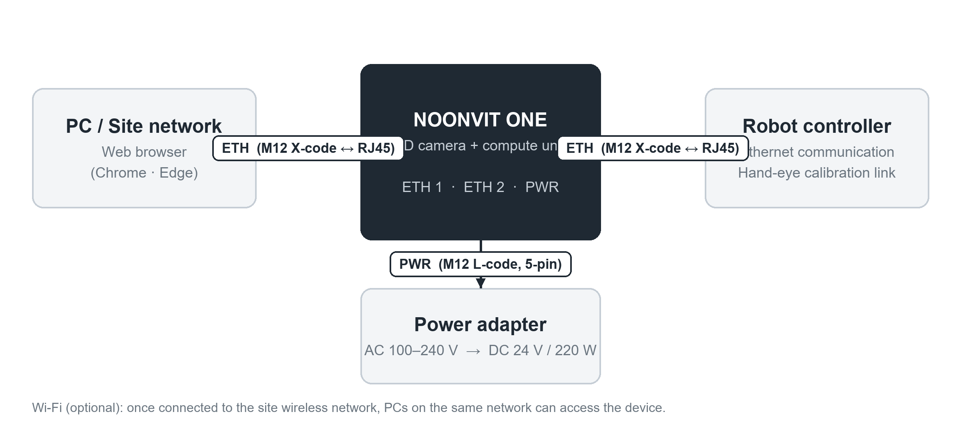
Figure 2-1 System Connection Configuration

Key Features
Feature | Description
All-in-one design | A 3D structured-light camera and an NVIDIA Jetson-based compute unit are integrated into a single body, minimizing installation space and wiring.
Browser-based operation | Configuration, monitoring, and process app execution are performed from a PC web browser without installing any additional software.
App-based process configuration | Process-specific functions such as inspection and calibration are installed and run as individual apps, so the system can be extended to meet site requirements.
Dual Ethernet | Two independent Gigabit Ethernet ports connect the robot controller and the site network at the same time.
Account-based access control | Users log in with a NOONVIT account to manage access rights and track the operating history of the device.

2.2 Package Contents
Open the package and check the contents against the list below. If any item is missing or damaged, notify your supplier or the manufacturer before installation.
Table 2-1 Package Contents
No. | Item | Qty. | Description
1 | NOONVIT ONE unit | 1 | Integrated 3D camera and compute unit, 2 Wi-Fi antennas fitted
2 | Power adapter | 1 | MEAN WELL GST220A24, input AC 100–240 V, output DC 24 V / 220 W
3 | Power cable | 1 | Adapter output (4-pin DIN) ↔ unit PWR (M12 L-code, 5-pin)
4 | Communication cable | 2 | Unit ETH (M12 X-code, 8-pin) ↔ RJ45, Cat.6A
5 | Mounting bracket and fasteners | 1 set | As per delivery specification (see mounting drawing)
6 | User manual | 1 | This document

2.3 Part Names
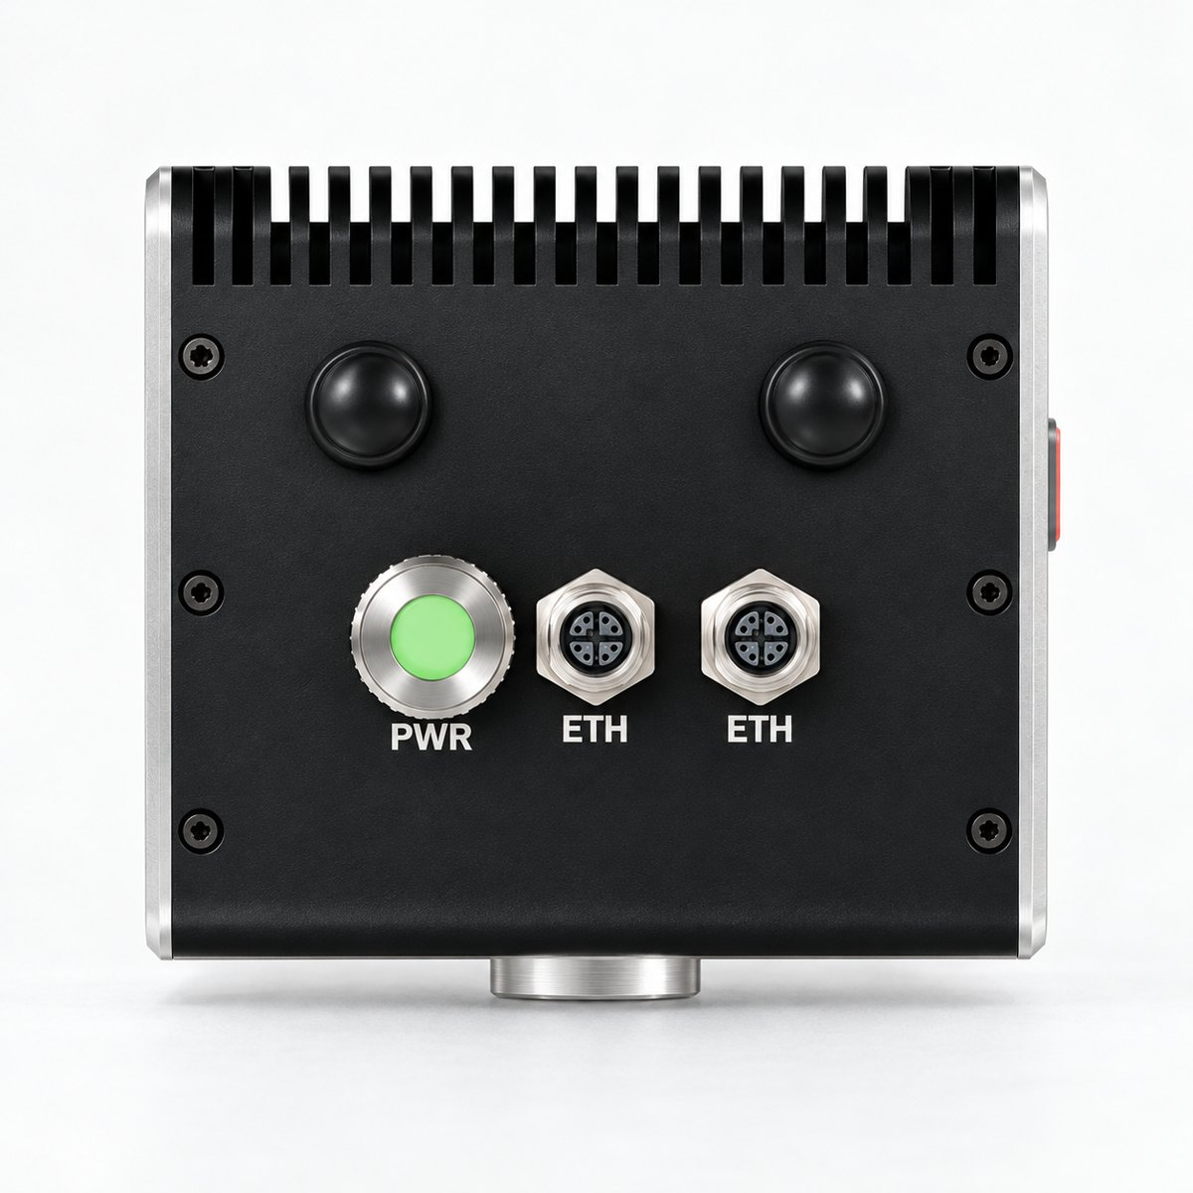
Figure 2-2 Front (left) and Rear (right)

Front
Name | Function
Optical window | Projector and receiver of the 3D camera. Blue pattern light is emitted during image capture. Keep the window free of contamination.
PWR button (orange ring) | Power button of the unit. The ring lights up while the power is on.
RST button (green ring) | Function button. Two short presses: Wi-Fi setup mode / 8 s or longer: restart / 12 s or longer: reset request (see Section 9.3)
Status indicators (4) | Indicate the status of the system, camera, Wi-Fi, and robot by color (see Section 6.3).

Rear
Name | Function
PWR connector | Power input DC 24 V. M12 L-code, 5-pin (male)
ETH connectors (2) | Gigabit Ethernet. M12 X-code, 8-pin (female). Connect one to the robot controller and the other to a PC or the site network.
ANT connectors (2) | Wi-Fi antenna connectors (RP-SMA). Use only the supplied antennas.
Heat sink | Top of the unit. May become hot during operation; do not block ventilation.

Mounting Surface
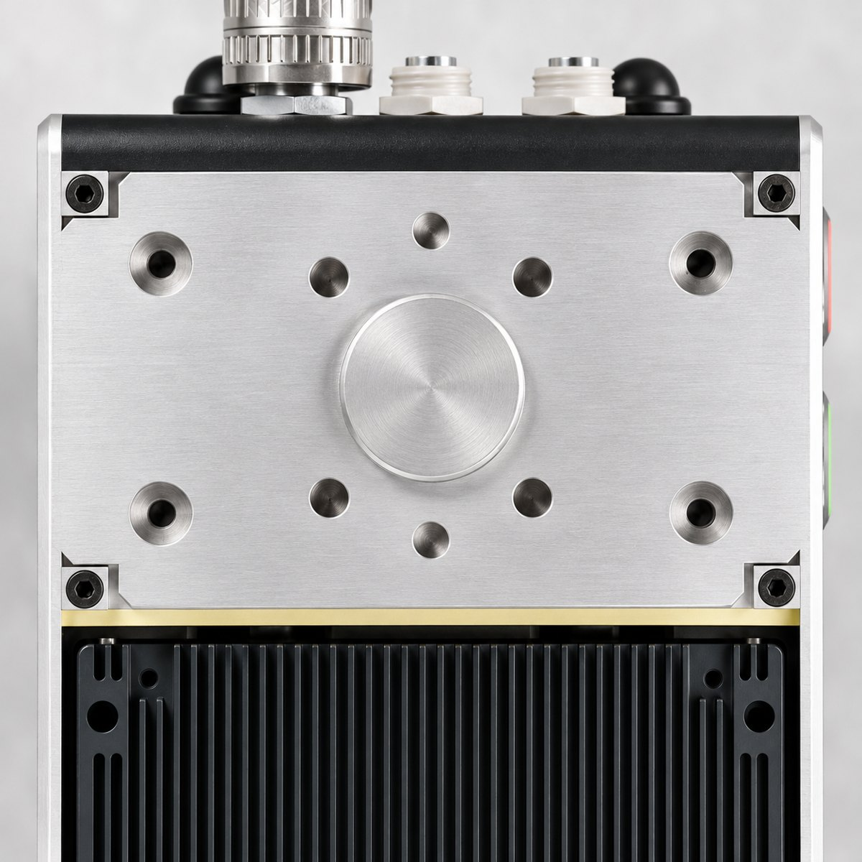
Figure 2-3 Mounting Surface and Mounting Holes
The circular boss in the center of the mounting surface is for positioning; the unit is fixed to the bracket using the surrounding mounting holes and dowel pin holes. Follow the approved mounting drawing for hole specifications, spacing, and tightening torque.

2.4 Specifications
Table 2-2 General Specifications
Product name | NOONVIT ONE
Model | NV-ONE-N350
Hardware revision | 1.0
Type | Robot-mounted 3D vision system (integrated 3D camera + compute unit)
Weight | Approx. 2.55 kg (unit only, excluding bracket)
Dimensions | See mounting drawing
Housing | Aluminum, finned heat sink on top / natural convection cooling
Operating environment | 0 to 45 ℃, 0 to 85 %RH (non-condensing), indoors

Table 2-3 3D Camera Specifications
Camera module | Mech-Mind Mech-Eye NANO ULTRA-GL
Method | Structured light, blue LED 440 nm, photobiological risk group RG2
Resolution | 2400 × 1800 (1200 × 900 selectable)
Working distance / field of view | 350 mm focus variant: 250 to 500 mm, 220 × 165 mm (0.25 m) to 500 × 340 mm (0.5 m)
 | 700 mm focus variant: 400 to 800 mm, 400 × 270 mm (0.4 m) to 770 × 550 mm (0.8 m)
Z repeatability (1σ) | 350 mm focus variant: 0.045 mm @ 0.4 m / 700 mm focus variant: 0.1 mm @ 0.6 m
Measurement accuracy (VDI/VDE 2634 Part 2) | 0.1 mm @ 0.4 m (350 mm focus variant), 0.1 mm @ 0.6 m (700 mm focus variant)
Capture time | 0.5 to 0.9 s (typical conditions)
2D image | Monochrome
Recommended warm-up time | 30 minutes

Table 2-4 Compute Unit Specifications
Compute module | NVIDIA Jetson Orin NX 16 GB
Carrier board | AVerMedia D131S
Processor | 8-core Arm Cortex-A78AE, NVIDIA Ampere GPU (1024 CUDA cores), AI performance up to 100 TOPS (INT8)
Memory | 16 GB LPDDR5
User interface | Web browser (latest version of Chrome or Edge recommended), access port 4000

Table 2-5 Interface and Power Specifications
Wired communication | 2 Gigabit Ethernet ports, M12 X-code, 8-pin
Wireless communication | Wi-Fi (Advantech AIW-170BQ module), 2 external antennas (RP-SMA)
Power input | DC 24 V, M12 L-code, 5-pin
Power adapter | MEAN WELL GST220A24 — input AC 100–240 V 50/60 Hz, output DC 24 V / 9.2 A (220 W)
Status indication | 4 front status indicators (RGB), PWR and RST button ring illumination

NOTE | The camera specifications are the values published by Mech-Mind. Record the focus variant (350 mm or 700 mm) of the delivered unit on the installation record card in Appendix A.  Measurement precision stabilizes only after the unit has been powered on for 30 minutes. Start precision measurement work after the warm-up is complete.

03

Installation

3.1 Pre-Installation Checks
- The unit weighs approximately 2.55 kg. Check the robot specifications to make sure that the total mass and center of gravity, including the bracket and cables, are within the allowable payload and allowable moment of inertia of the robot.
- Use a mounting bracket and fastening bolts of the specification given in the supplied mounting drawing.
- Check in advance that the unit and cables do not interfere with surrounding structures, fixtures, or workpieces throughout the entire working range of the robot.
- Make sure that the installation location meets the environmental conditions in Section 1.5.

3.2 Mounting on the Robot
WARNING | Perform the mounting work with the robot and equipment stopped and the power disconnected. If the robot moves during the work, serious injury may result.

- Stop the robot and the equipment and disconnect the power.
- Fix the bracket to the robot flange first.
- While supporting the unit, align the positioning boss on the mounting surface with the bracket and fasten the unit. Tighten the bolts in a diagonal sequence to the specified torque.
- Connect the cables (Section 3.3) and secure them, leaving slack near the robot joints. Make sure that the cables are not kinked or pulled at any point.
- Move the robot at low speed and check that the unit and cables do not interfere with their surroundings throughout the entire working range.

If the Mounting Position Has Changed
CAUTION | If the unit is removed and remounted or its position is changed, the positional relationship between the camera and the robot changes. Always perform hand-eye calibration again with the calibration app, check the result with a reference workpiece, and only then start work.

3.3 Cable Connection
Start with the AC plug of the power adapter unplugged.
- Insert the M12 connector of the power cable into PWR on the unit and turn it fully to lock it. Connect the other end (4-pin DIN) to the adapter output.
- Using the communication cables, connect one ETH to the robot controller and the other ETH to a PC or the site switch. Follow the installation record card for the use of each port.
- Secure the cables and check that they are not pulled or pinched anywhere when the robot moves.
- Plug the AC plug of the power adapter into an outlet.
NOTE | M12 connectors are screw-type. If a connector is not fully tightened, vibration may break the contact; if it is overtightened, the thread may be damaged. Turning it fully by hand provides the correct tightening force.

3.4 Powering On
When power is supplied, the system indicator blinks and booting starts; when booting is complete, the indicator changes to steady on. Then access the unit from a browser as described in Chapter 4.
Symptom | What to check
All indicators are off | Check in this order: AC plug → adapter indicator → PWR connector locked.
System indicator keeps blinking | Booting has not finished. If this continues for more than 5 minutes, refer to Chapter 10.
Smell, smoke, or excessive heat | Unplug the AC plug immediately and follow the procedure in Section 1.2.

3.5 Removal
Shut down the system using the procedure in Section 8.3, unplug the AC plug, and disconnect the cables after the heat sink has cooled. When removing the unit from the bracket, support it so that it does not fall.
04

Network Connection and Access
NOONVIT ONE is used from a web browser on a PC without installing any additional software. The latest version of Chrome or Edge is recommended. Use the access address recorded on the installation record card.

4.1 Access Address
Method | Address format | Example
IP address | http://<device IP>:4000 | http://192.168.10.20:4000
Device name | http://<device name>.local:4000 | http://noonvit-f4d38b.local:4000

The device name is unique to each unit and is recorded on the installation record card. Depending on your company network policy, the .local address may not open; in that case, use the IP address.

4.2 Wired Connection

When Connected to a Site Switch
The unit automatically obtains an IP address from the site network (DHCP). Ask your network administrator for the assigned address, or access the unit using the device name address.

When Connected Directly to a PC
The IPv4 address of the PC must be set manually to the same subnet as the unit. For example, if the unit address is 192.168.10.20, configure the PC as follows.
Item | Example value
Unit address / subnet mask | 192.168.10.20 / 255.255.255.0
PC address / subnet mask | 192.168.10.30 / 255.255.255.0 (only the last octet differs)
Browser address | http://192.168.10.20:4000

NOTE | The addresses above are examples for illustration and are not the factory settings. Restore the network settings of the PC to their original values when the work is finished.  The Camera IP shown in [Settings > Network & Time] is the dedicated address of the camera on the internal network of the unit; do not use it as the access address.

4.3 Wi-Fi Connection
In a wireless environment, once the unit has been connected to the site Wi-Fi, it can then be accessed from a PC on the same network.
- Press the RST button (green ring) on the front of the unit twice briefly. When the Wi-Fi indicator blinks purple, the unit is in setup mode.
- On a mobile phone or laptop, connect to the setup Wi-Fi (name and password on the installation record card).
- Open http://192.168.4.1/wifi in a browser, select the site Wi-Fi, and enter its password.
- When the connection is complete, the Wi-Fi indicator lights up blue. Switch the phone or PC to the site Wi-Fi and access the unit at the address in Section 4.1.
CAUTION | The disappearance of the setup Wi-Fi from the network list does not mean that the connection has succeeded. Confirm by the blue indicator and by actually accessing the unit. Find the newly assigned IP address in the DHCP records of your network administrator, or use the device name address.

05

Account Login
NOONVIT ONE is used by logging in with a NOONVIT account. An internet connection is required for login approval, and because the account status is checked periodically after login, the unit must remain connected to the internet during work as well.
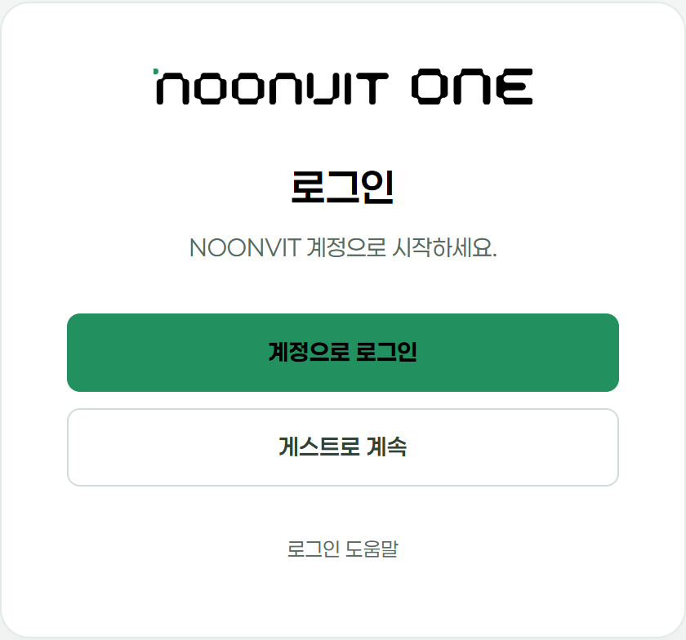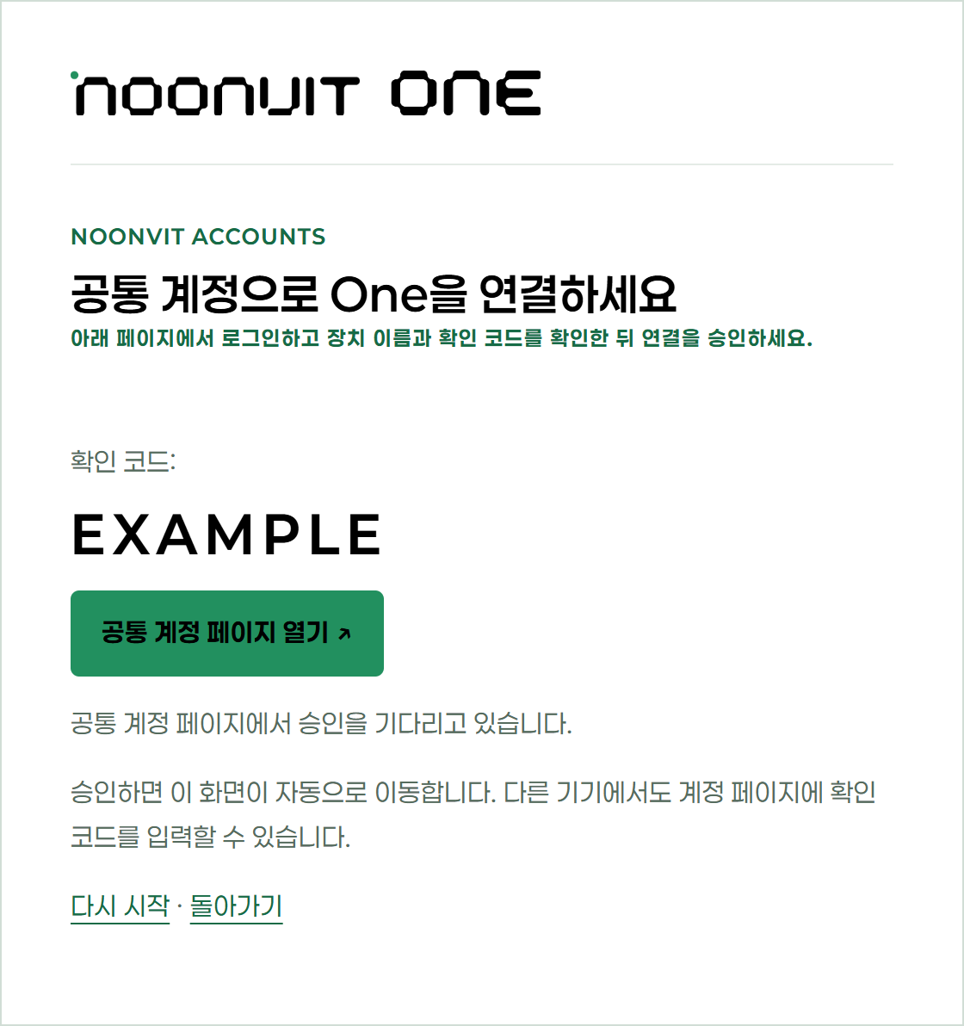
Figure 5-1 Login Screen (left) and Verification Code Approval Screen (right)

5.1 Login
- On the NOONVIT ONE screen, press [Sign in with account]. A verification code is displayed.
- Press [Open central account page] and log in with the account issued to you. The page may also be opened on another device, such as a mobile phone.
- Check that the device name and verification code shown on the account page match the unit you are currently accessing, and then approve.
- Login is complete when the NOONVIT ONE screen switches to Home and the account is shown in the upper right.
CAUTION | Do not approve if the device name or verification code differs. Doing so would grant access rights to another device. If the code has expired, press [Start over] to obtain a new code.

5.2 When Login Is Required Again
The login screen may be displayed again after the account status has expired or after the unit has been restarted. If the error "Cannot connect to account service" is displayed, check the internet connection of the unit and try again.

5.3 Guest Access
If you select [Continue as guest], you can view the screens, but some functions such as connection recovery are not available. Perform actual work by logging in with the account designated for the site.

5.4 Logout
When the work is finished, press [Log out] in the account menu in the upper right and check that the login screen is displayed again. When using a shared PC, always log out before handing it over to the next user.
INFO | Do not write down passwords or verification codes anywhere. If account information is leaked, notify the account administrator immediately.

06

Screen Layout and Status Indication

6.1 Main Menus
Menu | Function
Home | Shows the status of the unit, connected devices, and running apps at a glance.
Apps > My Apps | Runs and opens installed process apps.
Device Info | Shows the name, serial number, IP, and current connection status of the camera and robot.
Settings > Network & Time | Shows the dedicated camera network, cable status, and system time.
Settings > System & Maintenance | Shows the software version and storage space, and runs connection recovery.
Settings > Logs & Support | Manages log retention settings, change history, and diagnostic data for support.

6.2 Device Connection Status
In [Device Info], find the camera and robot required for the work, compare their name, serial number, and IP with the installation record card, and check the connection status and the last checked time. In configurations used without a robot, a robot connection is not required.
Indication | Meaning | Action
Checking | The unit has just booted or is checking the connection. | Wait a moment.
Connected | Normal. | Check that this is the device required for the work.
Not connected | The connection has been confirmed as lost. | Check the power, cables, and network.
Unknown | No recent information has been received. | Do not assume the connection is lost; first check the last checked time and the network of the PC.
Previously connected device | A record of a past connection. | Check the current connection status again.

NOTE | This screen only displays status. Opening or refreshing the screen does not connect any device or trigger image capture. The connection indication is unrelated to the emergency stop or servo status of the robot.

6.3 Status Indicators on the Unit
Table 6-1 Status Indicators
Indicator | Indication | Status
System | Blinking | Booting
 | On | Ready
 | Rapid red blinking | RST button held for 8 s (release to restart)
 | White blinking | RST button held for 12 s (waiting for reset confirmation)
Camera | White blinking | Connecting
 | Green on | Connected
Wi-Fi | White blinking | Not connected or connecting
 | Purple blinking | Setup mode
 | Blue on | Connected
Robot | White blinking | Connecting
 | Magenta on | Connected
 | Green on | Not connected

NOTE | The indicator colors are the factory settings and may be changed at installation.  A single short press of the RST button makes all four indicators blink white twice. This is only a confirmation of the button input and performs no other action. During work, a process app may display progress indications (such as sequential lighting).

07

Process Apps
Actual work such as inspection and calibration is performed in process apps. In [Apps > My Apps], use the app recorded on the installation record card, and check that the app name and version match the card.
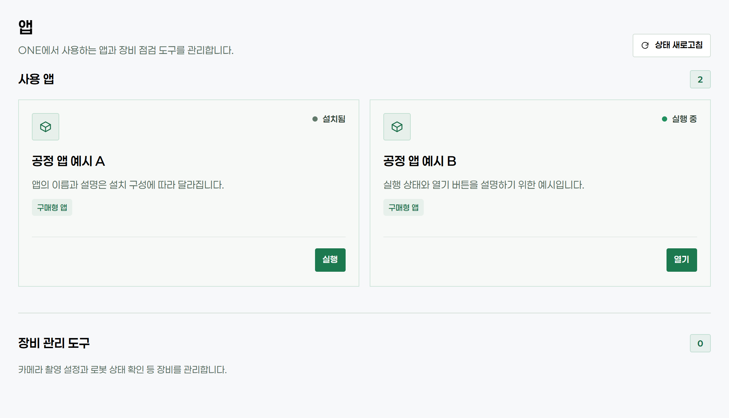
Figure 7-1 My Apps Screen

7.1 Running and Opening an App
- Find the app in [Apps > My Apps]. Apps shown under [More Apps] are not yet installed.
- If the status is "Installed", press [Run] and wait until the status changes to "Running". Do not press the button repeatedly.
- When the status is "Running", press [Open]. The app opens in a new window (tab).
- On the app screen, check that the workpiece and recipe are correct, and start the work according to the procedure in Chapter 8.

7.2 App Status After Restart
Whether an app runs automatically at boot depends on the startup setting of the app, and some apps do not support automatic start. After restarting the unit, check the actual status again in [My Apps]. Even if an app is "Running", the previous work does not resume automatically.

7.3 If the App Window Does Not Open
- Check the access address and the login account, and press [Refresh status].
- Check whether an app tab is already open.
- Click the pop-up blocked icon in the browser address bar and allow pop-ups for the NOONVIT ONE address.
If the window still does not open, record the app name, the error message, and the time of occurrence, and report them to the person in charge.
CAUTION | Closing the app window does not stop the app or the process. Follow the procedure of the app concerned to stop the process and save results.

08

Operation

8.1 Initial Installation Check
Before handing over to the operator, the installer checks the following items in order.
- Check the mounting and wiring (Chapter 3).
- Check browser access and login (Chapters 4 and 5).
- Check that the camera and robot are "Connected" in [Device Info].
- Perform hand-eye calibration with the calibration app.
- Inspect a reference workpiece with the process app and check that it is judged according to the pass criteria and that the result is saved and can be retrieved.
- Fill in the installation record card in Appendix A and the pre-handover checklist in Appendix B, and hand them over to the operator.

8.2 Daily Start-Up
Table 8-1 Daily Start-Up Checks
Step | Item | Action | Expected result
1 | Visual inspection | Visually check the optical window for contamination and the cables and bracket for looseness. | No contamination, damage, or looseness
2 | Power | Turn on the power and warm up for 30 minutes. | System indicator on
3 | Access | Access the unit at the address on the installation record card and log in. | Account shown on the Home screen
4 | Devices | Check the camera and robot status in [Device Info]. | All required devices "Connected"
5 | Verification | Open the process app and inspect a reference workpiece once. | Judged according to the pass criteria

CAUTION | If an error or an unusual result occurs, stop the process and record the error message and the time. Do not change the inspection criteria arbitrarily before the cause has been identified. First check whether the recipe, mounting, lighting, or network has been changed recently.

8.3 End of Work
- Complete or stop the work in the process app, and check that the robot and surrounding equipment are in a safe state.
- Check that the results have been saved, and then log out.
- Turn off the unit with the PWR button. Do not assume that the unit is off just because the browser window has been closed or the screen connection has been lost.
- Before removing or cleaning the unit, unplug the AC plug and wait until the heat sink has cooled.

8.4 If the Power Is Lost Unexpectedly
Before turning the power back on, check that the equipment is in a safe state. After powering on, check the login, device connections, and app status in order, and check in the app whether the result of the last work was saved. Inspect a reference workpiece once before resuming work.
09

Maintenance

9.1 Periodic Inspection and Cleaning
Table 9-1 Periodic Inspection
Interval | Inspection items
Daily | Contamination or damage of the optical window, looseness of cables and connectors, bracket fastening
Monthly | Dust on the heat sink, clearance for ventilation, cable fixing and sheath damage
After mounting change | Interference check in the working range, repeat of hand-eye calibration, reference workpiece inspection

Cleaning Method
- Perform cleaning with the power off and after the heat sink has cooled.
- Wipe the housing with a dry, soft cloth. Do not spray water or use abrasives or strong solvents.
- Wipe the optical window gently with a lens cloth or an air blower, and check the result with a reference workpiece after cleaning.

9.2 Recovering Connections from the Screen
If a device connection or app problem persists, trained personnel use [Settings > System & Maintenance > Recovery]. Account login is required. Stop the process first, and run only the one item that is needed.
Recovery item | Action | Caution
Recover robot connection | Rechecks robot control authority and device identification. | A teach pendant program in progress may stop.
Recover camera connection | Checks that it is the same camera and reconnects it. The IP and saved settings are retained. | Not executed during image capture or saving.
Restart current app | Runs the selected app again. | Work in progress and unsaved temporary results are lost.
Restart all software | Restarts the apps, device services, and main server. | Saved settings are retained; work does not resume automatically.

Check for the "Recovery complete" or failure message. If the screen connection is lost briefly, press [Recheck status] after it is reconnected. After recovery, check the device connections and work conditions, and restart the work manually.

9.3 Restarting and Resetting with the Button
When the screen cannot be accessed, you can restart the unit or request a reset with the RST button (green ring) on the front of the unit. Stop the process first.
Operation | Action
Hold for 8 s or longer, then release | When the system indicator blinks red rapidly, release the button to restart the unit.
Hold for 12 s or longer, then release | When the system indicator blinks white, the unit is waiting for reset confirmation. Press and hold the button again for 3 s or longer within 10 s to request a reset; if left as is, the request is canceled.

CAUTION | Use the reset function only when instructed by service personnel. After a reset, the network settings and account link may need to be configured again.

9.4 Log Retention
In [Settings > Logs & Support], you can check the log retention period, the storage space warning threshold, and the change history. These settings apply only to system logs and are separate from the retention period of inspection results. Saving and exporting results is performed in the process app.
10

Troubleshooting
If a problem occurs, first put the equipment in a safe state. Recording the on-screen message, the time of occurrence, and the actions already taken avoids repeating the same operations and speeds up technical support.

10.1 Check Sequence by Symptom
Table 10-1 Check Sequence by Symptom
Symptom | Check sequence
Screen does not open | Check in this order: system indicator → cable or Wi-Fi indicator → PC network settings → address and port (:4000).
Cannot access after Wi-Fi setup | Check that the PC is connected to the same site Wi-Fi. Find the new IP of the unit in the DHCP records or use the device name address.
Login or approval fails | Check the internet connection of the unit and the PC, and the device name and verification code. If the code has expired, obtain a new code.
Logout error | Check the internet connection and try again. Confirm that the login screen is displayed before handing over the PC.
App missing or does not open | Check: access address and account → [Refresh status] → list of installed apps → existing tabs and pop-up blocking (Section 7.3).
Device not connected | Check: status and checked time in [Device Info] → device name and IP → power, cables, and network. If the problem is not resolved, consider recovery as described in Section 9.2.
Inspection results differ from usual | Check in this order: optical window contamination → 30-minute warm-up → reference workpiece and recipe → mounting condition, lighting, and vibration → recent changes. Report both normal and abnormal results to the person in charge.
Heat, smell, or damage | Disconnect the power immediately. Do not turn the unit back on until it has been inspected by service personnel.

10.2 Requesting Technical Support
Prepare the following information when requesting technical support.
- Device name (or serial number) and installation location
- Time and frequency of occurrence, and the app and recipe in use
- Exact error message and a screenshot, recent changes, and actions already taken
In [Settings > Logs & Support > Diagnostic Data for Support], you can check what data is included using [Preview included items]. Previewing alone does not send any data. Follow the instructions of service personnel for how to deliver the data, and mask passwords and verification codes before sending.
11

Warranty and Service

11.1 Warranty
The warranty period and conditions of the product are as stated in the supplied warranty certificate and supply agreement. Manufacturing defects that occur under normal conditions of use during the warranty period will be repaired or replaced free of charge.

Warranty Exclusions
- Failures caused by installation, use, or storage not in accordance with the instructions in this manual
- Failures caused by disassembly or modification of the product, or by the use of accessories not specified by the manufacturer (adapters, cables, antennas, etc.)
- Damage caused by external factors such as dropping, impact, water ingress, fire, lightning, or abnormal voltage
- Natural wear of consumable parts such as the optical window, cables, and connectors
- Repairs performed by anyone other than the manufacturer or designated service personnel

11.2 Service Contact
For product inquiries, technical support, and repair requests, contact us as shown below. Providing the device name (or serial number) with your inquiry allows us to respond more quickly.
Table 11-1 Service Contact
Manufacturer | WithPoints Co., Ltd.
Address | 2F, 8 Gukjegwahak 11-ro, Yuseong-gu, Daejeon 34002, Republic of Korea
Tel. | +82-42-721-0412
Email | info@withpoints.co.kr
Support hours | Weekdays 09:00–18:00 (KST, excluding Korean public holidays)

If a site service representative has been separately designated, use the contact on the installation record card in Appendix A first.
A

Appendix

A Installation Record Card
To be filled in by the installer before handover and updated whenever a change is made. Do not record passwords or verification codes.
Item | Record
Unit | Model NV-ONE-N350 HW Rev. 1.0 Device name __________ Serial No. __________
Camera focus variant | □ 350 mm □ 700 mm
Installation location | Line / equipment __________ Robot model __________
Access address | http://______________________:4000
Wired ports | ETH for PC / site network ____ (IP __________) ETH for robot ____ (IP __________)
Wi-Fi | □ Used □ Not used Site SSID __________ Setup Wi-Fi name __________
Camera / robot | Camera serial No. __________ Robot controller IP __________
Process app | App name / version __________ App manual location __________
Reference work | Reference workpiece __________ Recipe __________ Pass criteria __________
Result storage | Storage / retrieval location ______________________
Personnel | Account issued by __________ Installer __________ Operator __________
Service contact | ______________________
Installation / handover date | Year 20____ Month ____ Day ____

B Pre-Handover Checklist
No. | Check item | Result
1 | Mounting and wiring have been checked, including interference within the robot working range. | □ Done □ Not done
2 | Accessed and logged in at the address on the card, and confirmed that the camera and robot are "Connected". | □ Done □ Not done
3 | After calibration, the reference workpiece result met the pass criteria. | □ Done □ Not done
4 | Saving and retrieving results, stopping the process, and shutting down the unit have been performed together with the operator. | □ Done □ Not done
5 | The installation record card has been filled in and handed over to the operator. | □ Done □ Not done

Record any incomplete items and special remarks in the site handover record.
Installer | Name ____________ Signature ____________ Date ____________
Recipient | Name ____________ Signature ____________ Date ____________

WITHPOINTS
WithPoints Co., Ltd.
2F, 8 Gukjegwahak 11-ro, Yuseong-gu, Daejeon 34002, Republic of Korea
Tel. +82-42-721-0412 · info@withpoints.co.kr
Business Registration No. 501-86-01277 · CEO Dong-kyun Cho
NVO-UM-EN-002 · Rev. 2.1 · October 21, 2026 · Printed in Korea

